Section 1: Case Summary

Scenario Title: | Respiratory Failure with Protected Intubation
Keywords: | COVID-19, intubation, communication
Brief Description of Case: | A 70-year old woman who is known COVID-positive presents with hypoxic respiratory failure and requires urgent intubation. This needs to be done in a negative pressure room with airborne PPE. Communication between the team members inside and outside the room must be maintained throughout the clinical care.

Goals and Objectives
Educational Goal: | Practice a protected intubation according to local protocols, with attention to personal and team safety, effective team communication and safe intubation.
Objectives:  (Medical and CRM) | - Organize the healthcare team by using a pre-procedure briefing  - Maintain effective team communication throughout the procedure, including the team members outside the negative pressure room  - Minimize personal risk by utilizing the appropriate donning/doffing of PPE  - Perform high acuity clinical care (intubation) using local guidelines
EPAs Assessed: | None

Learners, Setting and Personnel
Target Learners: | ☒ Junior Learners |  | ☒ Senior Learners |  |  | ☐ Staff
 | ☐ Physicians | ☐ Nurses |  | ☐ RTs | ☐ Inter-professional
 | ☐ Other Learners:
Location: | ☒ Sim Lab |  | ☐ In Situ |  |  | ☐ Other:
Recommended Number of Facilitators: | Instructors: 1
 | Confederates: 2
 | Sim Techs: 1

Scenario Development
Date of Development: | April 15, 2020
Scenario Developer(s): | Dr Chris Heyd, MD
Affiliations/Institutions(s): | McMaster University
Contact E-mail: | christopher.heyd@medportal.ca
Last Revision Date:
Revised By:
Version Number:

Section 2A: Initial Patient Information

- Patient Chart
Patient Name: Mary Francis |  |  |  | Age: 70 | Gender: F | Weight: 70kg
Presenting complaint: Short of breath
Temp: 38.1 | HR: 95 | BP: 110/70 |  | RR: 30 | O₂Sat: 81% | FiO₂: 100%
Cap glucose: 6.1 |  |  |  | GCS: 15 (E V M )
Triage note: Patient coming from home where she is isolating. Known COVID+. Non-productive cough for six days. Now increasing short of breath for two days. EMS found patient tachypneic with an SpO2 in the 70s on room air.

Allergies: NKDA
Past Medical History:  Hypertension |  |  | Current Medications:  Ramipril 5mg daily

Section 2B: Extra Patient Information

A. Further History
Include any relevant history not included in triage note above. What information will only be given to learners if they ask? Who will provide this information (mannequin’s voice, confederate, SP, etc.)?

HPI & PMHx: As above triage note.
Social History: Patient independent at home, recently retired office worker, FULL CODE.
B. Physical Exam
List any pertinent positive and negative findings
Cardio: Nil | Neuro: Nil
Resp: 2-3 work dyspnea, coarse bilateral crackles | Head & Neck: Nil
Abdo: Nil | MSK/skin: Nil
Other: Nil

Section 3: Technical Requirements/Room Vision

A. Patient
☒ Mannequin (Adult)
☐ Standardized Patient
☐ Task Trainer
☐ Hybrid
B. Special Equipment Required
Intubation supplies
Telecommunication devices (speakerphone, walkie-talkie, baby monitor, etc)
Ideally, a physical barrier or second room to use so that the “inside team” and “outside team” are separated and must use a telecommunication device to communicate.

C. Required Medications
RSI kit (COVID-specific)

D. Moulage
Elderly woman

E. Monitors at Case Onset
☐ Patient on monitor with vitals displayed
☒ Patient not yet on monitor
F. Patient Reactions and Exam
Include any relevant physical exam findings that require mannequin programming or cues from patient
(e.g. – abnormal breath sounds, moaning when RUQ palpated, etc.) May be helpful to frame in ABCDE format.

Breathing – Coarse Crackles throughout all lung fields

Section 4: Confederates and Standardized Patients

Confederate and Standardized Patient Roles and Scripts
Role | Description of role, expected behavior, and key moments to intervene/prompt learners. Include any script required (including conveying patient information if patient is unable)
RT  (inside room) | Prepares intubation equipment and ventilator. Assists during intubation. Can be more or less hands-on depending on the training level of the participants.
Charting RN  (outside room) | Stays outside the room, recording pertinent information. Uses telecommunication device to gather the information.

Section 5: Scenario Progression

Scenario States, Modifiers and Triggers
Patient State/Vitals | Patient Status | Learner Actions, Modifiers & Triggers to Move to Next State |  | Facilitator Notes
1. Baseline State  EMS patches in with above triage note |  | Expected Learner Actions  Recognize need for intubation  Assign team roles  Gather medications  Gather supplies  Pre-procedure briefing  Discuss rescue plans | Modifiers  Triggers  5 min → Patient arrival
2. Patient Arrival  Rhythm: Sinus  HR: 95  BP: 110/70  RR: 30  O₂SAT: 81% (NRB)  T: 38.1ºC  GCS: 15 | Tachypneic  Dyspneic | Expected Learner Actions  Don PPE then enter room  Check communication device  Confirm code status  Brief history/physical exam  Secure IV access  Prepare ventilator  Team member to call ICU  Preoxygenate  Consider proning | Modifiers  Triggers  All action complete → Intubation
3. Intubation  O₂SAT: 81% (NRB)  GCS: 3 (after intubation meds given) | Paralyzed | Expected Learner Actions  Pre-intubation time out to review plan  Push RSI meds  Wait 60 seconds  Intubation | Modifiers  RSI meds given: SpO2 drops to 70%  Triggers  Passed tube → Post-intubation
4. Post-Intubation  RR: 12  O₂SAT: 90% (vent) |  | Expected Learner Actions  Confirm tube placement  Safely attach ventilator  Provide sedation  Doff PPE  Call ICU (if not yet done) | Modifiers  Triggers  Doff PPE → End case

Appendix A: Laboratory Results

No labs given during case

Appendix B: ECGs, X-rays, Ultrasounds and Pictures

No imaging given during case

Appendix C: Facilitator Cheat Sheet & Debriefing Tips

Early in the COVID-19 pandemic, new protocols and procedures were developed to maximize provider safety during high risk clinical activities such as intubation and cardiac arrest resuscitation. Initially, learners were excluded from performing these procedures but as time went on and this restriction was relaxed, we realized that they needed practice before following these new protocols for actual patients.

We re-arranged our sim lab to more closely reflect the challenges faced in the actual emergency department. Some of the adjustments we made to our lab:
- Stripped out all equipment and made participants think about what they needed to take in
- Narrowed the medications available for RSI and sedation
- Kept the sim tech and charting nurse outside of the room and used a speakerphone or walkie-talkies to communicate between the inside and outside of the negative pressure room
- Used a white noise machine to simulate a HEPA filter
- Used expired or washable PPE (especially N95 masks) to simulate the communication barrier they create
- Assigned a confederate to inside the room (RT) and outside the room (charting RN) to get feedback from both sides of the wall

Some Sample Questions for Debrief:
- What were some barriers to effective communication? How were these overcome (or could be overcome in the future)?
- What information did you include in the pre-brief? Was anything missed? Did you use a checklist or tool, and was it helpful?
- How was this intubation different from your typical intubations? How did those differences make you feel?
- What strategies did you use to ensure safe donning and doffing of PPE?
- Discuss various non-invasive ways to improve oxygenation. Which of these are allowed at your institution?

*Below is one infographic highlighting key changes from usual intubation from the FOAM website CanadiEM. Note that as understanding of COVID grows, protocols will change to incorporate best practices and older resources may be obsolete.

**Use your most up to date local Protected Intubation protocol.

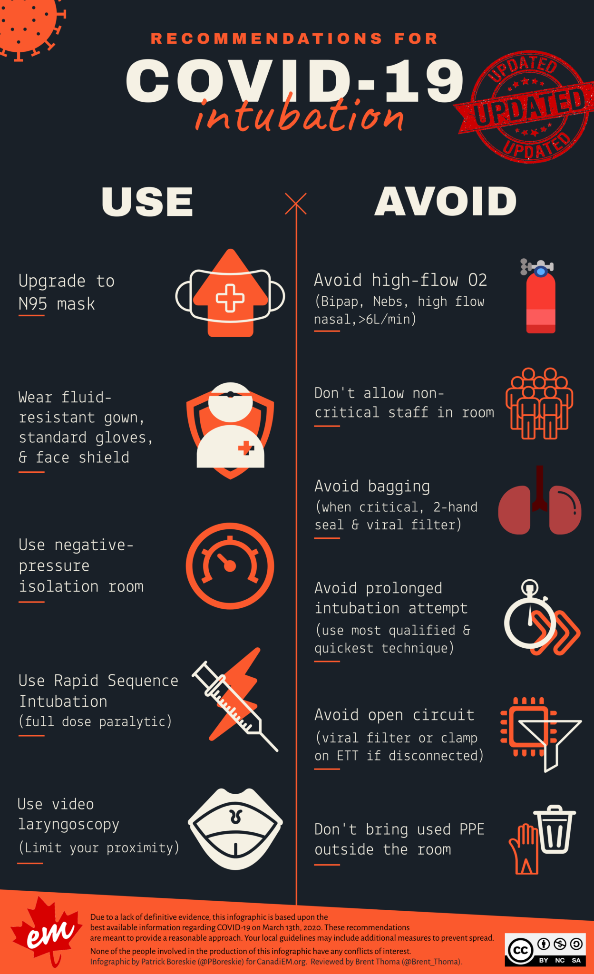
Source: https://canadiem.org/recommendations-for-covid-19-intubation-an-infographic/

References

1. https://emergencymedicinecases.com/covid-19-protected-intubation/
2. https://empendium.com/mcmtextbook/covid-19/234191,covid-19-mcmaster-survival-guide
3.

